**MSBI INTRODUCTION:**

• MSBI stands for MicroSoft Business Intelligence.

• MSBI is nothing but its process of converting data into information.

• It works with companies and provide access and exact data up to date. It helps all the companies to make decisions accurately, they can implement future plans with the time.

**Advantages of MSBI:**

• Faster reporting, analysis or planning.

• More accurate reporting, analysis or planning.

• Better business decisions.

• Improved data quality.

• Improved employee satisfaction.

• Improved operational efficiency.

• Improved customer satisfaction.

• Increased competitive advantage.

• Reduced costs.

• Increased revenues.

• Saved headcount.

**Why MSBI?**

1. Backlog of business requests.
2. Need for self-service BI.
3. Messed up IT system.
4. Cost.

**What the users want?**

• Data should be completely integrated across the network.

• Summarized data should have real value to the organization.

• Historical data unlocks the path to understand the health of organization.

• “What-If” capability must be there in the data.

**MSBI Components:**

1. **SSIS: •** SQL Server Integration Service.

• Integration Tool.

1. **SSAS: •** SQL Server Analytical Service.

• Analytical Tool / Analysis Tool.

1. **SSRS: •** SQL Server Reporting Service.

• Reporting Tool / Data View Tool.

**MSBI Architecture:**

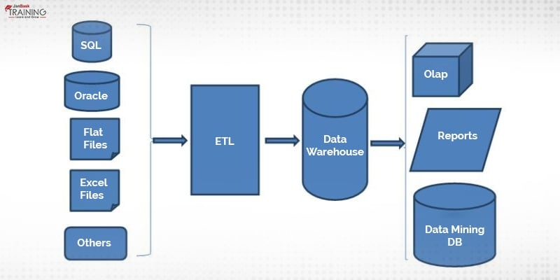

### **SSRS (SQL Server Reporting Services):**

• SRS is an enterprise reporting platform that supports traditional and interactive reports delivered over the web using custom apps.

• It can support multiple data sources together, either two-dimensional or multi-dimensional.

• As the name suggests, the tool is highly recommended for robust documentation and reporting.

• It is an efficient report generation platform, and reports generated by the tool can be used anywhere for almost any application.

**Features:**

* It can retrieve data from multiple sources in different formats.
* It allows web-based access to reports as needed.
* It gives wonderful support for ad-hoc reporting.
* It has a report builder mechanism for customizing reports as per the requirement of end-users.
* The tool has easy subscription options that attract users around the globe.
* It exports features and functionalities in different formats.
* It displays reports in different ways like Tabular, [**Pie Charts**](https://www.janbasktraining.com/blog/ssrs-pie-chart/), Gauge, etc.

**Applications:**

* The tool can be used for free, so Companies love to adopt it for basic reporting features.
* The tool gives you enterprise-level features even for the free version.
* It can be integrated with multiple databases like SQL, Oracle, Excel, and more.
* The tool can be utilized to build, distribute, and access reports over the web.
* It can work with different development programs like [Visual Studio](https://visualstudio.microsoft.com/) or [ADO.net](https://docs.microsoft.com/en-us/dotnet/framework/data/adonet/ado-net-overview), etc.
* It helps in scheduling the delivery of reports automatically, and this feature is extremely helpful for people who run their reports regularly.
* The SSRS tool has a huge support community, not from Microsoft only but a plethora of users worldwide.